Introduction

As an INDIAN we cannot forget 26/11 when 200 people including nine foreigners and 14 policemen have lost their lives while about 118 people were injured in the worst terror attack seen in the country in which desperate men fired indiscriminately at people. Being an INDIAN my blood was boiling as our brave soldiers were fighting the militants to free all the hostages from mumbai hotels and to trash out the terrors from our motherland…..!!!

We made a study regarding this; we found that lack of planning is one of the main reasons for such a mass losses of lives. Since there was no devices like camera to monitor the right positions of the terrorists and hostage peoples. So the militants had only a way of direct attack even uncared of their lives. And it struck an idea in our mind, “ why cant we make a robot to tackle such type of situation...? ” .

COMMANDO ROBOT

BLOCK BIAGRAM - RECEIVER

M2
M1
Motor Driver
RF Tx-Rx
Wi-Fi
Camera

PIC
16F877A

BLOCK DIAGRAM – TRANSMITTER/REMOT CONTROL

Keypad
RF Tx-Rx
Wi-Fi
Camera Rx

PIC
16F877A
Circuit Operation

The Heart of our robot is microchip’s most powerful PIC-16 family, we are using two PIC-16F877A microcontrollers. One is used in the robot’s vehicle and other one for the remote. This is a midrange microcontroller which has numerous inbuilt functions and has 8KB of Flash ROM inbuilt. The inbuilt ADC is one of the most functions of this family. The robot consists of two parts; one is the transmitter side and other is the receiver (control) side.

Receiver Section:

The receiver section consists of two DC motor wheels which moves the robot. A balancing front wheel is also attached with it for proper balancing of vehicle. Thus wireless transmission is done and can be watched through a computer monitor. A pair of laser gun is attached with the camera helps for proper aiming of guns. RF433-RX is 433MHz radio receiver which receives the transmitted codes from the remote place transmitted by the transmitter, these codes are converted to digital format and out put is made available.

A Wi-Fi camera is used for the transmission of real-time video. The video can be seen through a computer monitor. Since the Wi-Fi camera we can allow the robot to a lot more distance and get a high quality video output. So each and every tiny observation can be done through the robot.
Based on the input codes robo will behaves as follows:
- Moves in forward direction.
- Moves in reverse direction.
- Speed controls in both the direction.
- It can even turn left or right while moving forward or in reverse direction.
- Instant reverse or forward running without stopping.
- In case of bump, moves reverse turn left or right and wail for the next instruction.
- On the spot left or right turn to pass through the narrow space.

Transmitting Section:

The transmitting or controlling section consist of keypad for various operations. Micro switches interfaced with PIC microcontroller is the keypad. The keypad is used to control the robo.

The movement of robo is controlled by this keypad. The following functions can be performed on the keypad.

- Start/stop.
- Increase speed.
- Increase speed.
- Direction change.
- Turn left.
- Turn right.

Circuit Diagram

Receiver:
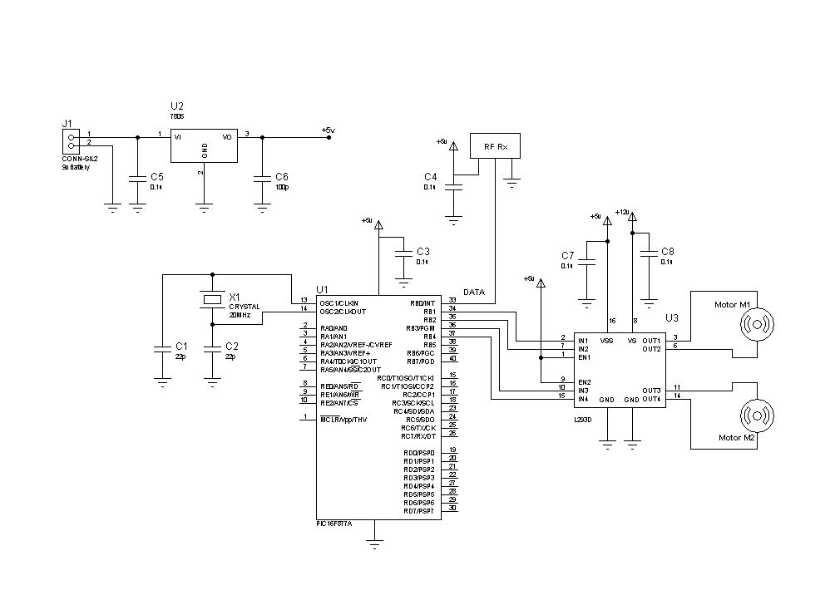

Transmitter:

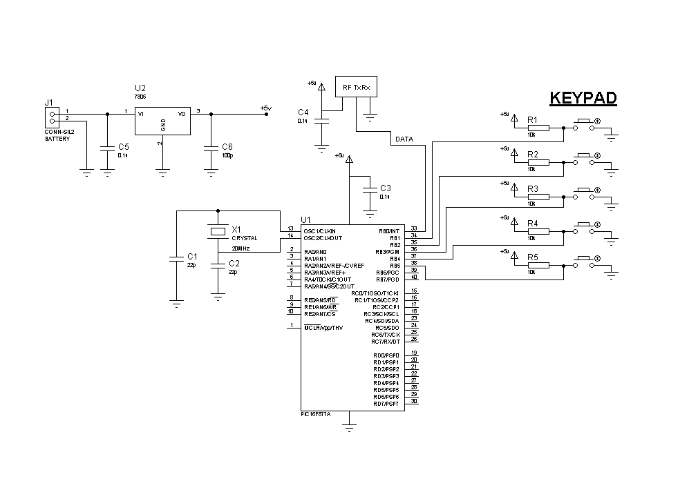

Components List

Semiconductors:
IC1 (U1) - PIC 16F877A microcontroller
IC2 (U2) - LM 7805 voltrage regulator
IC3 (U3) - L293D motor driver
RX1,RX2 - RX-433 RF (AFK) transmitter,receiver
Resistors(all ¹/₄ –watt, ±5% carbon):
R1 – R5 - 10-kilo-ohm
Capacitors:
C1,C2 - 22pF, ceramic disk
C3,C4,C5,C7,C8 - 0.1µF, ceramic disk
C6 - 100pF, ceramic disk
Miscellanius:
X_{TAL} - 20MHz crystal
S1 – S5 - Micro Switch
M1,M2 - 12v,60-rpm geared DC motor
Battery - 12v,4.5Ah rechargeable battery, 9v battery
- SIL2 connector
Description Of Components

Microcontroller – PIC 16F877A

The Microcontroller is a set of logic circuits integrated on a single silicon ‘chip’ whose connections and behaviour can be specified and later altered when required, by the program in its memory. The great advantage of this is that in order to change the circuit’s structure and operation, all that is needed is a change in the program very little, if any, circuit hardware modification are necessary.
Here we use the microcontroller PIC 16F877A. The PIC 16F8XX series fits perfectly in these such applications for low power transmitters/receivers. PIC 16F877A is an 8-bit, fully static, EEPROM/EPROM/ROM based CMOS microcontroller. It employs RISC architecture with only 35 words/single cycle instructions. All the instructions are single cycle (1µs) except for program branches which take two cycles. The PIC 16F8XX products are supported by a full featured macro assembler, a software, ‘C’ compiler, etc.

Pin Diagram – PIC 16F877A
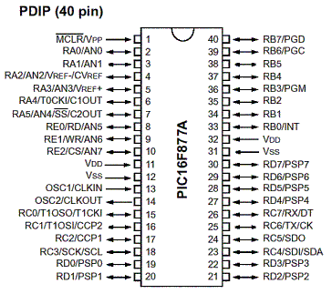

2. Power and Charging Section

A rechargeable battery of 12v is used in our robot to provide sufficient power. The battery is fitted on the lower part of the robot. The +ve and -ve terminals of battery is connected to SIL2 connector. A 15v power supply adaptor is sufficient to recharge the battery. The output from SIL2 connector is connected to a +5v regulator (7805). Two capacitors are connected at the input and output of the regulator to avoid any noise voltages. Thus regulated +5v output is generated for the working of PIC microcontroller and for many of the components used.

Another 9v battery is used in the remote section to provide sufficient power for the working of remote control. A +5v regulator(7805) is used to get the regulated output of +5v. This 5v is enough for the PIC microcontroller and most of the components used in this section.

3. Crystal

The crystal is the main part of PIC microcontroller since a stable clock frequency is necessary for its working. Though we have a lot of options are available to provide an oscillator, but they are not stable. So we use a crystal oscillator. Crystal oscillators are very stable oscillators. It consist of a crystal, which produce oscillation.

A crystal of 4 – 20Mhz can be used in a PIC microcontroller. Here use 20MHz crystal for high speed of operation. For the 20MHz crystal 22pF ceramic disk capacitors are preferred to use for avoiding any noise signals and provide better stability maintenance.

4. RF-433MHz Transmitter, Receiver

RF-433MHz Transmitter:
The STT-433 is ideal for remote control applications where low cost and longer range is required. The transmitter operates from a 1.5-12V supply, making it ideal for battery-powered applications. The transmitter employs a SAW-stabilized oscillator, ensuring accurate frequency control for best range performance. Output power and harmonic emissions are easy to control, making FCC and ETSI compliance easy. The manufacturing-friendly SIP style package and low-cost make the STT-433 suitable for high volume applications.

Features:
- 433.92 MHz Frequency
- Low Cost
- 1.5-12V operation
- 11mA current consumption at 3V
- Small size
- 4 dBm output power at 3V
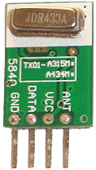
RF 433 MHz Receivers:
The STR-433 is ideal for short-range remote control applications where cost is a primary concern. The receiver module requires no external RF components except for the antenna. It generates virtually no emissions, making FCC and ETSI approvals easy. The super-regenerative design exhibits exceptional sensitivity at a very low cost. The manufacturing-friendly SIP style package and low-cost make the STR-433 suitable for high volume applications.

- Low Cost
- 5V operation
- 3.5mA current drain
- No External Parts are required
- Receiver Frequency: 433.92 MHZ
- Typical sensitivity: -105dBm
- IF Frequency: 1MHz
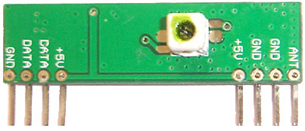
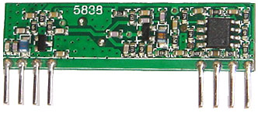

5. L293 Motor Driver

The L293 and L293D are quadruple high-current half-H drivers. The L293 is designed to provide bidirectional drive currents of up to 1 A at voltages from 4.5 V to 36 V. The L293D is designed to provide bidirectional drive currents of up to 600-mA at voltages from 4.5 V to 36 V. Both devices are designed to drive inductive loads such as relays, solenoids, dc and bipolar stepping motors, as well as other high-current/high-voltage loads in positive-supply applications.

Program

Area of Application

- Military Application

While considering a life as so valuable than a little money, our new combat robot works well in these situations.Our new Combat robot is radio operated , it has got two barrel turret through bullet can be fired, Wi-Fi camera in synchronization with the turret can rotate up and down ,left and right up to a safe firing limit. Turret and camera mechanism which has all the function like tank, turning to any angle on its axis, moving forward and reverse turning left and right, running instantly into reverse direction.

This robo is radio operated; self powered, and has all the controls like a normal car. A pair of laser gun can been installed on it, so that it can fire on enemy remotely when required; this is not possible until a wireless camera is installed. Wireless camera will send real time video and audio signals which could be seen on a remote monitor and action can be taken accordingly. It can silently enter into enemy area and send us all the information through its’ tiny camera eyes. It is designed for, fighting as well as suicide attack.

One click destroying of enemies is the another advantage of our new combat robot. When we attach an RF bomb like explosives; while in an emergency situation we can explode it using one click. This facility needs some special implementation.

2. Industrial Application
Since the militants take the entire rescue to serve and protect the people. Like any other militant our “COMMANDO” is also just like a soldier which take rescue of not only the attacks but also serves in Industries. Our “COMMANDO” can add some sensors like:
- Gas Leakage and warn with voice alarming.
- Temperature Monitoring.
- Metal detection, etc.

The Robot makes on time monitoring of industrial plants and make warnings regarding the issues. So it helps to avoid or escape from any dangerous situations and disasters. By the help of a monitor the person can supervise the plant using this robot.

It is very helpful in a nuclear plant at a dangerous situation for knowing the situation inside the plant and none of the human can enter into the plant, our combat robot can take that rescue. It is also helpful in the petroleum industries for finding any cracks or leakage of huge pipes where no humans can enter, our robo can allowed inside and the problems can be analysed and the precautions and solutions can be found by the engineers easily.

Advantages

- This circuit is simple to use and efficient.
- It can be assembled with ease.
- It is cheap and hence very economic.
- Wide range of operation.
- Multipurpose usages.

Disadvantages and Solutions

- Range limit inside 100meters.

- Can be avoid by using higher technologies like Zigbee, etc.

- Noise in wheels.

- Usage of chain wheels avoid noise.

Printed Circuit Board

PCB FABRICATION

Printed circuits boards play a vital role here in determining the overall performance of electronic equipment .A good PCB design ensures that the noise introduced as a result of component placement and track layout is held within limits while still providing components years of assembly maintenance and performance reliability.

Where and Why are PCB’s used?

Printed circuits boards are used to route electric signals through copper track which are firmly bonded to an Insulating base.

Advantages of PCB over common wiring are:

1. PCB’s are necessary for connecting a large number of
electronic components in a very small area with minimum
parasitic effects.

2. PCB’s are simulated with mass production with less chance of
writing error.

3. Small components are easily mounted.

4. Servicing is simplified.

The base materials used for PCB’s are glass epoxy, epoxy paper, polyester etc. Copper foil used for copper clad is manufactured by the process of electronic deposition .The properties of copper foil are:

Thickness………………35μ meter
Thickness tolerance……+5 μ meter
Purity of Copper………99.8%
Resistivity at 20◦C…….0.1594

PREPARATION OF SINGLE SIDED PCB NEEDS:

- LAYOUT
- FABRICATION
- ETCHING
- DRILLING
- SOLDERING

COST ESTIMATION

Sl: No: | Components | Specification | Quantity | Cost
1 | Pic µc | 16f877a | 2 no | 2x250 = 500
2 | Voltage Regulator | LM 7805 | 2 no | 2x8 = 16
3 | Motor Driver | L293D | 1 no | 1x25 = 25
4 | Rf Transmitter | STT 433 | 1 no | 1x275 = 275
5 | Rf Receiver | STR 433 | 1 no | 1x350 = 350
6 | Resistors | 10k ¹/₄ watt | 5 no | 5x20p = 1
7 | Capacitors | Ceramic Disk | 8 no | 8x50p = 4
8 | X_{TAL} | 20MHz | 2 no | 2x15 = 30
9 | Micro Switch | - | 5 no | 5x3 = 15
10 | Geared DC Motor | 12v, 60-rpm | 2 no | 2x150 = 300
11 | Battery | 12v,4.5Ah  9v DC | 1 no  1 no | 1x850 = 850  1x30 = 30
12 | Camera | Wi-Fi | 1 no | 1x8000 = 8000
13 | PCB | - | 1 no | 1x250 = 250
14 | Copper Etchant | Feric Chloride | 1kg | 1x125 = 125

Conclusion

With the little knowledge in electronics and computer programming we could make an application like

“ Combat Robot ”

This circuit nowadays has high economical value since the life of our brave soldiers are very valurable. So this would be a great dedication to my mother land. And with low cost, cheap availability and the technology implementation, it makes a great demand.

